PASTOR: Msgr. Brian G. Sheehan
SUNDAY LITURGY
Saturday: 5:00 pm
Sunday: 11:00 am
BAPTISMS: By Appointment
Please call the Rectory (506) 653.6855
CONFESSIONS: Saturday 4:00 pm – 4:30 pm
MARRIAGES: Six months’ notice

SUNDAY, APRIL 21ST, 2024
Welcome to those who are visiting with us today!
MASSES FOR THE WEEK:
MON. 9:00 am - Richard McLean
TUES. 9:00 am - Audrey Leahey (Anniv)
WED. 9:00 am - Mary Noel
THURS. 9:00 am - Ronald M. Shannon (Anniv)
FRI. 9:00 am - No Mass
SAT. 5:00 pm - Harold/Mark Lenihan
SUN. 11:00 am - Deceased Members of Doherty
& Loughery Families

The Sanctuary Lamp for the week of April 22nd – April 28th is In Memory of LeBlanc & Guthrie Families donated by Mary Guthrie.

KNIGHTS OF COLUMBUS 17984 BREAKFAST: Sunday, April 21st, from 9:00 am– 1:00 pm in Assumption Centre. Adults -- $10, children (12 years & under) $4.

KEEP YOUR PARTNER 45’S CARD GAME: There will be no Card Game in May…
SUNDAY OFFERING: April 14th, 2024
Envelopes $ 2,030.00 Thank You for your
Loose 223.00 continued generosity!
Auto Debit (PAD) 1,242.00
TOTAL $ 3,495.00

Eucharistic Ministers – April 27th & 28th
SAT. ~ 5:00 pm: M. Quinn (H1), N. Murphy (H2)
SUN. ~ 11:00 am: C. Gray (H1), P. Loughery (H2)

Lectors – April 27th & 28th
SAT: ~ 5:00 pm: Linda Laforge
SUN: ~ 11:00 am: Connor Sullivan

CARLETON CHORISTERS (Christer Lane, Director/Claire Driscoll, (piano)
– Celebrate Music, featuring Seaside Elementary School, Mary Ann Melvin, director. Sunday, May 26, 2024 at 2:00 pm in Our Lady of the Assumption Church. Tickets: $20, available at the door or from Choristers, carletonchoristers.com

UPCOMING EVENTS
CASINO – Assumption Centre
June 8th from 7:00 pm – 9:00 pm
More information to follow….

My dear Parishioners:
Words escape me to express adequately my gratitude to you for your prayers, cards, expressions of support on the occasion of my recent accident and fall on the rectory’s stairs.
I deeply felt your support during my recovery.
Let us keep praying for each other.

Gratefully in Christ,
Msgr. Sheehan

THOUGHT TO PONDER…
Go the extra mile, it’s not crowded…

ASSUMPTION CENTRE: For hall rental bookings, (weddings, graduation parties, showers, birthday parties, business meetings –seminars – workshops, please call (506) 672-7691 and leave a message or call/text Philip Armstrong (506) 721.4949

TUESDAY NIGHT BINGO: Sponsored by K of C 17984. Msgr. Osborne Family Centre – 6:00 pm, doors open at 5:30 pm. Snack and Tea supplied. Canteen available.

FOOD BANK - On the first weekend of the month (May 4/5) we are asking parishioners to bring non-perishable items which can be placed around the Altar at each Mass. (In most need of - cereal, pancake mix, syrup, jam & toiletries). These items will then be donated to the West Side Food Bank. Thank you for your continued support!

THE K OF C COUNCIL 17983 monthly rosary and adoration service will be held ON Thursday, April 25th, 6:30 pm in St. Rose worship site. All Welcome!

The next monthly Mass for those Living with Cancer, will be celebrated on Tuesday, May 21st at 7:00 pm in the Cathedral. The Anointing of the sick will be offered.

OUR LADY OF THE ASSUMPTION PARISH
360 Dufferin Row, Saint John, NB
Phone: (506.653.6855)
E-mail assumptionparish@nb.aibn.com

APRIL 21ST, 2024
FOURTH SUNDAY OF EASTER

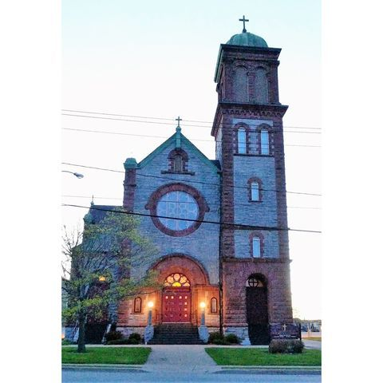

MISSION STATEMENT
We are a welcoming Christian community called to
embrace and respect the uniqueness of each individual
as we join together in our faith and worship. Our ongoing
mission is to engage our youth, promote renewal, outreach,
evangelization and ecumenical cooperation.

