PASTOR: Msgr. Brian G. Sheehan
SUNDAY LITURGY
Saturday: 5:00 pm
Sunday: 11:00 am
BAPTISMS: By Appointment
Please call the Rectory (506) 653.6855
CONFESSIONS: Saturday 4:00 pm – 4:30 pm
MARRIAGES: Six months’ notice

SUNDAY, APRIL 28TH, 2024
Welcome to those who are visiting with us today!
MASSES FOR THE WEEK:
MON. 9:00 am - Vincent Richard
TUES. 9:00 am - Florence Maillet
WED. 9:00 am - Olive Martin
THURS. 9:00 am - Dr. Joseph Hazel
FRI. 9:00 am - First Friday – Art Barrieau (Anniv)
SAT. 5:00 pm - Roy Lord
SUN. 11:00 am - John Montague (Anniv)

The Sanctuary Lamp for the week of April 29th – May 5th is In Memory of Monica & Joseph Armstrong donated by Blake Armstrong.

KNIGHTS OF COLUMBUS 17984 BREAKFAST: Sunday, May 12th, from 9:00 am– 1:00 pm in Assumption Centre. Adults -- $10, children (12 years & under) $4.

KEEP YOUR PARTNER 45’S CARD GAME: There will be no Card Game in May…
SUNDAY OFFERING: April 21st, 2024
Envelopes $ 3,390.00 Thank You for your
Loose 258.00 continued generosity!
Auto Debit (PAD) 1,242.00
TOTAL $ 4,890.00

POPES PASTORAL WORKS: There will be a second collection next weekend (May 4/5) for Papal Charities. Canada has been consistent in giving funds to the Holy See, enabling the Pope to be even more generous in times of disaster. Every year at this time, Canadian Catholics are asked to give generously to the papal collection, which is passed on to the Holy Father for his use among those stricken by national disasters.

The next monthly Mass for those Living with Cancer, will be celebrated on Tuesday, May 21st at 7:00 pm in the Cathedral. The Anointing of the sick will be offered.

Eucharistic Ministers – May 4th & 5th
SAT. ~ 5:00 pm: J. Jarvis (H1), J. Gidney (H2)
SUN. ~ 11:00 am: P. Brillant (H1), A. Gray (H2)

Lectors – May 4th & 5th
SAT: ~ 5:00 pm: Tom Bishop
SUN: ~ 11:00 am: Alexandra Sullivan

CARLETON CHORISTERS (Christopher Lane, Director/Claire Driscoll, (piano) – Celebrate Music, featuring Seaside Elementary School, Mary Ann Melvin, director. Sunday, May 26, 2024 at 2:00 pm in Our Lady of the Assumption Church. Tickets: $20, available at the door or from Choristers or carletonchoristers.com

UPCOMING EVENTS
CASINO – Assumption Centre
June 8th from 7:00 pm – 9:00 pm
More information to follow….
THOUGHT TO PONDER…
Be an encourager. The world has plenty of
critics already…

ASSUMPTION CENTRE: For hall rental bookings, (weddings, graduation parties, showers, birthday parties, business meetings –seminars – workshops, please call (506) 672-7691 and leave a message or call/text Philip Armstrong (506) 721.4949

TUESDAY NIGHT BINGO: Sponsored by K of C 17984. Msgr. Osborne Family Centre – 6:00 pm, doors open at 5:30 pm. Snack and Tea supplied. Canteen available.

FOOD BANK - On the first weekend of the month (May 4/5) we are asking parishioners to bring non-perishable items which can be placed around the Altar at each Mass. (In most need of - cereal, pancake mix, syrup, jam & toiletries). These items will then be donated to the West Side Food Bank. Thank you for your continued support!

Steubenville Atlantic 2024 Youth Conference – Youth aged 14-18 are invited to participate in this event held at Saint Mary’s University in Halifax, NS from July 5-7. If you are between 18 and 21, you can attend as a peer leader. Before registering, please talk to your parish priest or RE coordinator about registration. Conference information can be found on the Archdiocese of Halifax-Yarmouth website under Steubenville Atlantic. Transportation to NS is included in the registration fee of $300.00. Pick up locations will be from Fredericton, Saint John, and Moncton. For more information, please contact Patricia Lee at catechesis@dioceseofsaintjohn.org or 506-627-6465.

OUR LADY OF THE ASSUMPTION PARISH
360 Dufferin Row, Saint John, NB
Phone: (506.653.6855)
E-mail assumptionparish@nb.aibn.com

APRIL 28TH, 2024
FIFTH SUNDAY OF EASTER

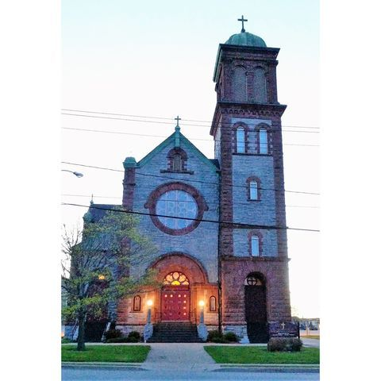

MISSION STATEMENT
We are a welcoming Christian community called to
embrace and respect the uniqueness of each individual
as we join together in our faith and worship. Our ongoing
mission is to engage our youth, promote renewal, outreach,
evangelization and ecumenical cooperation.

