PASTOR: Msgr. Brian G. Sheehan
SUNDAY LITURGY
Saturday: 5:00 pm
Sunday: 11:00 am
BAPTISMS: By Appointment
Please call the Rectory (506) 653.6855
CONFESSIONS: Saturday 4:00 pm – 4:30 pm
MARRIAGES: Six months’ notice

SUNDAY, APRIL 7TH, 2024
Welcome to those who are visiting with us today!
MASSES FOR THE WEEK:
MON. 9:00 am - Rick Dashwood
TUES. 9:00 am - Mary Noel
WED. 9:00 am - Nancy Saulnier
THURS. 9:00 am - Bernadette LeBlanc
FRI. 9:00 am - No Mass
SAT. 5:00 pm - Leo & Melina LeBlanc
SUN. 11:00 am - Gautreau/Kiervin Families & DMF

The Sanctuary Lamp for the week of April 8th – April 14th is In Memory of Tim Cameron donated by the Family.

EXPOSITION OF THE BLESSED SACRAMENT: Sunday, April 7th, St. Rose of Lima from 1:00 pm – 2:00 pm.

KEEP YOUR PARTNER 45’S CARD GAME: Sunday, April 14th, 1:00 pm in Assumption Centre. Price $10/couple.

SUNDAY OFFERING: March 31st, 2024
Envelopes $ 3,095.00 Thank You for your
Loose 1,125.00 continued generosity!
Auto Debit (PAD) 1,242.00
TOTAL $ 5,462.00

Good Friday $ 1,910.00
Easter $ 3,380.00

Eucharistic Ministers – April 13th & 14th
SAT. ~ 5:00 pm: J. Gidney (H1), J. Jarvis (H2)
SUN. ~ 11:00 am: M. McAuliffe (H1), P. Stoddard (H2)

Lectors – April 13th & 14th
SAT: ~ 5:00 pm: Paulette Stoddard
SUN: ~ 11:00 am: Georgia Anderson

KNIGHTS OF COLUMBUS 17984 BREAKFAST: Sunday, April 24th, from 9:00 am– 1:00 pm in Assumption Centre. Adults -- $10, children (12 years & under) $4.

UPCOMING EVENTS

CASINO – Assumption Centre
June 8th from 7:00 pm – 9:00 pm

More information to follow….

THOUGHT TO PONDER…
Courage to continue matters more than
success or failure…

ASSUMPTION CENTRE: For hall rental bookings, (weddings, graduation parties, showers, birthday parties, business meetings –seminars – workshops, please call (506) 672-7691 and leave a message or call/text Philip Armstrong (506) 721.4949

FOOD BANK - On the first weekend of the month (April 6/7) we are asking parishioners to bring non-perishable items which can be placed around the Altar at each Mass. (In most need of - cereal, pancake mix, syrup, jam & toiletries). These items will then be donated to the West Side Food Bank. Thank you for your continued support!

SOLEMNITY OF THE ANNUNCIATION OF THE LORD: Bishop Riesbeck will be presiding the 12:10 Mass at the Cathedral on Monday, April 8th to celebrate the Solemnity of the Annunciation of the Lord. In response to Pope Francis’ invitation to all Catholics, we will renew the act of consecration to the Immaculate Heart of Mary at the end of Mass.

The next monthly Mass for those Living with Cancer, will be celebrated on Monday, April 15th at 7:00 pm in the Cathedral. Anointing of the sick will be offered.

OUR LADY OF THE ASSUMPTION PARISH
360 Dufferin Row, Saint John, NB
Phone: (506.653.6855)
E-mail assumptionparish@nb.aibn.com

APRIL 7TH, 2024
SECOND SUNDAY OF EASTER

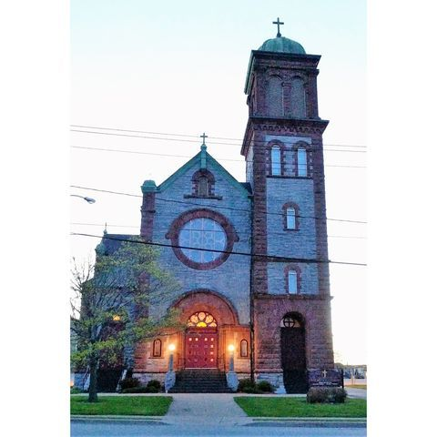

MISSION STATEMENT
We are a welcoming Christian community called to
embrace and respect the unique ness of each individual
as we join together in our faith and worship. Our ongoing
mission is to engage our youth, promote renewal, outreach,
evangelization and ecumenical cooperation.

