PASTOR: Msgr. Brian G. Sheehan
SUNDAY LITURGY
Saturday: 5:00 pm
Sunday: 11:00 am
BAPTISMS: By Appointment
Please call the Rectory (506) 653.6855
CONFESSIONS: Saturday 4:00 pm – 4:30 pm
MARRIAGES: Six months’ notice

SUNDAY, MAY 5TH, 2024
Welcome to those who are visiting with us today!
MASSES FOR THE WEEK:
MON. 9:00 am - Imelda Gautreau (Anniv)
TUES. 9:00 am - Geraldine & Allen Abbott
WED. 9:00 am - Dr. Joseph Hazel
THURS. 9:00 am - Nancy Bourgeois
FRI. 9:00 am - No Mass
SAT. 5:00 pm - Shirley Farrah
SUN. 11:00 am - Leo Olsen (Anniv)

The Sanctuary Lamp for the week of May 6th – May 12th is In Memory of John Montague donated by the Family.

KNIGHTS OF COLUMBUS 17984 BREAKFAST: Sunday, May 12th, from 9:00 am– 1:00 pm in Assumption Centre. Adults -- $10, children (12 years & under) $4.

KEEP YOUR PARTNER 45’S CARD GAME: There will be no Card Game in May…

SUNDAY OFFERING: April 28th, 2024
Envelopes $ 3,590.00 Thank You for your
Loose 158.00 continued generosity!
Auto Debit (PAD) 1,242.00
TOTAL $ 4,990.00

POPE’S PASTORAL WORKS: There will be a second collection this weekend (May 4/5) for Papal Charities. Canada has been consistent in giving funds to the Holy See, enabling the Pope to be even more generous in times of disaster. Every year at this time, Canadian Catholics are asked to give generously to the papal collection, which is passed on to the Holy Father for his use among those most in need throughout the world.

Eucharistic Ministers – May 11th & 12th
SAT. ~ 5:00 pm: H. Myers (H1), B. Armstrong (H2)
SUN. ~ 11:00 am: V. Harrity (H1), R. Finley (H2)

Lectors – May 11th & 12th
SAT: ~ 5:00 pm: Shirley Olsen
SUN: ~ 11:00 am: Georgina Stafford

CARLETON CHORISTERS (Christopher Lane, Director/Claire Driscoll, (piano) – Celebrate Music, featuring Seaside Elementary School, Mary Ann Melvin, director. Sunday, May 26, 2024 at 2:00 pm in Our Lady of the Assumption Church. Tickets: $20, available at the door or from Choristers or carletonchoristers.com

KNIGHTS OF COLUMBUS, COUNCIL 0616, 4TH DEGREE is having a Casino night on Saturday, June 8th from 7:00 pm – 9:00 pm in Assumption Centre, 721 Chapel Street. Admission: $20 (will buy you $20,000 in casino cash). Door open – 6:30 pm. Bar, Silent Auction (cash only) & 50/50 Draw. Proceeds to benefit needed repairs to the entrance stairs of Assumption Rectory.

THOUGHT TO PONDER…
Maybe you are searching among the branches,
for what appears only in the roots…
- Rumi

ASSUMPTION CENTRE: For hall rental bookings, (weddings, graduation parties, showers, birthday parties, business meetings –seminars – workshops, please call (506) 672-7691 and leave a message or call/text Philip Armstrong (506) 721.4949

TUESDAY NIGHT BINGO: Sponsored by K of C 17984. Msgr. Osborne Family Centre – 6:00 pm, doors open at 5:30 pm. Snack and Tea supplied. Canteen available.

FOOD BANK - On the first weekend of the month (May 4/5) we are asking parishioners to bring non-perishable items which can be placed around the Altar at each Mass. (In most need of - cereal, pancake mix, syrup, jam & toiletries). These items will then be donated to the West Side Food Bank. Thank you for your continued support!

Steubenville Atlantic 2024 Youth Conference – Youth aged 14-18 are invited to participate in this event held at Saint Mary’s University in Halifax, NS from July 5-7. If you are between 18 and 21, you can attend as a peer leader. Before registering, please talk to your parish priest or RE coordinator about registration. Conference information can be found on the Archdiocese of Halifax-Yarmouth website under Steubenville Atlantic. Transportation to NS is included in the registration fee of $300.00. Pick up locations will be from Fredericton, Saint John, and Moncton. For more information, please contact Patricia Lee at catechesis@dioceseofsaintjohn.org or 506-627-6465.

The next monthly Mass for those Living with Cancer, will be celebrated on Tuesday, May 21st at 7:00 pm in the Cathedral. The Anointing of the sick will be offered.

OUR LADY OF THE ASSUMPTION PARISH
360 Dufferin Row, Saint John, NB
Phone: (506.653.6855)
E-mail assumptionparish@nb.aibn.com

MAY 5TH, 2024
SIXTH SUNDAY OF EASTER

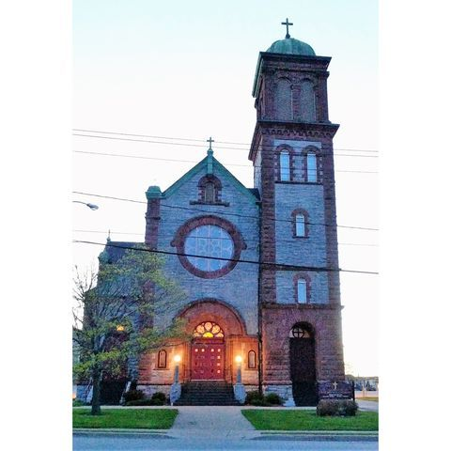

MISSION STATEMENT
We are a welcoming Christian community called to
embrace and respect the uniqueness of each individual
as we join together in our faith and worship. Our ongoing
mission is to engage our youth, promote renewal, outreach,
evangelization and ecumenical cooperation.

